**Applications of Colorimetry to Snow Crab**

**INTRODUCTION**

**Shell Condition**

Shell or carapace condition of snow crab has been used since the very beginnings of the annual trawl survey in 1988. A set of visual and tactile criteria were developed to provide the biologist or technician with a means of qualitatively assessing the relative age of a snow crab’s carapace from the time of its’ last moult.

Shell condition has many applications. Firstly, as that snow crab have a final or terminal when mature, shell condition is used to separate spring-moulted crab from those which moulted in previous years, allowing assessment biologists to quantify annual recruitment to the fishery, which in turn can be used to estimate annual mortality: quantities which are key inputs to either predictive (SSR 2016 ref) or population dynamics models. Secondly, the relative abundance of older shell conditions in the commercial component also provides an important indicator of fishing intensity. Thirdly, a recent phenomenon in sSGL crab stocks has been a high abundance of skip-moulting crab. These are juvenile crab which, as the moniker implies, do not undergo their regular annual moult, leading to a delay in recruitment to the fishery and unpredictability in the population dynamics.

The present study aims to test whether colorimeter measurements can be used to reliably predict shell condition, possible as a replacement method in future surveys or sampling protocols. Since shell condition may vary annually, seasonally and spatially, variations over time and space in the relationship between the colorimeter and the biologist will need to be considered when evaluating the performance of the instrument.

**Egg Development and Maturity Stages:**

* Qualitative color assessments of eggs and gonad colours have been made onboard snow crab surveys since year XXXX.
* The colour of the hepatopancreas may be used to gauge diet and condition of individuals.
* Mature females are conjectured to have reproductive cycles of one or two years which may vary from year to year or by the region.
* The diagnosis of the reproductive cycle of the female is difficult.
* Colorimeter measurements may allow the classification of females into one or two-year reproductive cycle.
* The link between objective colorimeter measurements and qualitative colour measures on gonads and eggs could then be extended to past survey observations.
* Also of interest are the regional and seasonal variations in gonad, egg and hepatopancreas colours.
* What were the annual, seasonal and regional variations in gonad and egg colour in past surveys? This needs to be explored…

**METHODS**

**Description of Shell Condition:**

* Shell condition is currently ranked into five or more categories, depending on the type of sampling, ranging from newly moulted to crab to those who moulted many years prior.
* These categories identified using such criteria as iridescence of certain portions of the carapace, epibiont coverage and relative hardness of the carapace.
* We need a full description of these criteria…

**Sampling**

* In September 2015, 269 adult males were measured using a colorimeter during a tagging project on CSS Perley.
* A Konica-Minolta CR-400 Chroma Meter was used to measure the colour at each of 5 different locations on the carapace, one on the dorsal side and four on the ventral side, with the aim of determining which location provided better predictions of observed shell condition.
* These regions are as follows: 1) Intestinal region on dorsal surface, 2) 3rd abdominal segment (ventral), 3) Thoracic sternite, 4) Merus of the 2nd pereopod (lower ventral side), and 5) Cheliped (lower ventral side) (see Figure 1).
* Measured colour was recorded as a triplet of values in the CIELAB color space, the first being a measure of luminosity *L\**, and the two others measuring chromaticity *a\** and *b*.
* Three measurements were done at each location and colour recorded as the average of the three.
* However, the samples for 2015 had no shell condition 2 individuals, which limited the usefulness of the sample, as distinguishing between this category and other categories was one of the main objectives of the study.
* So in May and June of 2016, colour measurements were made on fishermen’s catches which did contain some shell condition 2 individuals.
* The cheliped was identified as the optimal location for predicting shell condition using this data set, and samples were gathered in July and September for this location only.
* Table 1 provides a summary of the number of samples by year, month, location for each shell condition.
* **Perhaps a breakdown by fishing vessel would also be relevant...**

**Table 1**: Summarizes the number of samples by month and shell condition for 2016 data.

|  |  |  |  |  |  |  |  |  |
| --- | --- | --- | --- | --- | --- | --- | --- | --- |
|  |  |  |  | **Shell Condition** | | | | |
| **Year** | **Month** | **Zone** | **Sex** | **2** | **3** | **3M** | **4** | **5** |
| 2015 | September | 19 | Male |  | 18 | 154 | 97 |  |
| 2016 | May | 12 | Male | 103 | 0 | 1 | 96 | 3 |
| 2016 | June | 12 | Male | 0 | 37 | 117 | 41 | 0 |
| 2016 | July | 19 | Male | 166 | 33 | 194 | 385 |  |
| 2016 | September | 19 | Male | 3 | 15 | 386 | 1981 |  |

* The total number of observations was $n=392$.
* Although samples were measured at all five locations in 2015, the sample did not contain crab with shell condition 2, so it was left out of the analysis.
* Owing to their rarity, shell condition 5 individuals were also removed from the analysis.

**INFORMATION :**

* *CIE : Commission Internationale de l'Eclairage*
* convertColor*:* Function to convert colours into RGB values in R. Maybe include circles of example colours corresponding to cluster centers or points on the colour graph.
* *Delta-E : difference between two colours*
  + *CIE76 formula : ${∆E}_{ab}^{*}=\sqrt{{(L_{2}^{*}-L_{1}^{*})}^{2}+{(a_{2}^{*}-a_{1}^{*})}^{2}+{(b_{2}^{*}-b_{1}^{*})}^{2}}$*
  + There is a more complicated CIE94 formula as well
  + A difference of ~2.3 corresponds to what is termed a *Just Noticeable Difference* (JND).
* L* ranges from 0 to 100. a* and b* values range from -128 to 127.

**IDEAS**

* Multivariate clustering methods to perform “Colour quantitzation”, i.e. partition the colour space into discrete groups, which will be interpreted as belonging to different maturity schedules or reproductive periods.
* Gaussian multivariate copulas seemed interesting, but likelihood may not be analytical, i.e. it seems to require that empirical marginal distributions to be combined with the copula.
* A finite mixture of asymmetric multivariate distributions would work nicely…with very few components.
* Plot fertility results from lab observations and explain the variation that is seen.
  + There seems to be a “super-gravid” type of multiparous female in certain samples, but not obviously in the OERA samples.
  + Make sure that the presence of this group is not the result of lab error.
  + Build a two-component Gaussian regression mixture. Examine how the proportion varies by qualitative variables as well as crab size.
  + Try to link membership within the super-gravid group to gonad or egg mass characteristics.

**Things to do …**

**Female samples:**

* Quality images (i.e. good lighting) of **egg** color stages (light orange, dark orange, black, cocoon) , **gonad** color stages (white, beige, orange) and **hepato-pancreas** (a simplified Moriyasu scale, perhaps?). Also relevant are intermediate examples.
* Find a way to convert the CEILAB colours to approximate colours which could be graphically displayed or printed out.
* Develop multivariate mixture-based clustering models for identifying sub-groups of samples. These *a priori* groupings can then be compared to qualitative observations, such as sampler-based color observations.
* Develop multinomial regression models which predict various qualitative observations, such as gonad colors, egg colors and egg development stages.
* Summary table of female colorimeter samples.
* Summary table of female fertility samples.
* What is the extent of the area scanned by the colorimeter?

**Samples goals / research questions:**

* Check observer-based qualitative color observations against objective colorimeter measurements.
* Check variations in time and location of color of various snow crab organs.
* Check if it possible to classify samples by reproductive period.
* Check if it is possible to classify samples according to whether it follows a single or two-year reproductive cycle.
* Reconcile groupings with heterogeneity in the fecundity data.

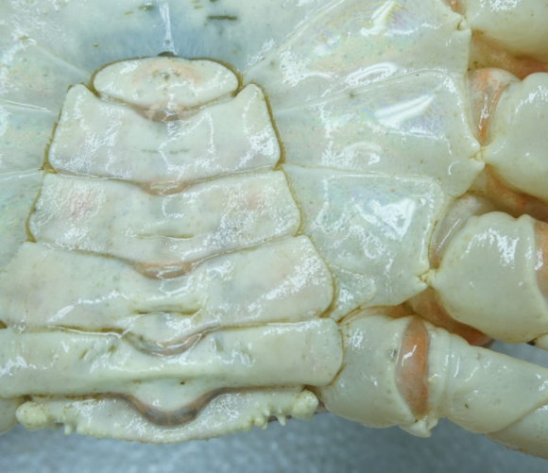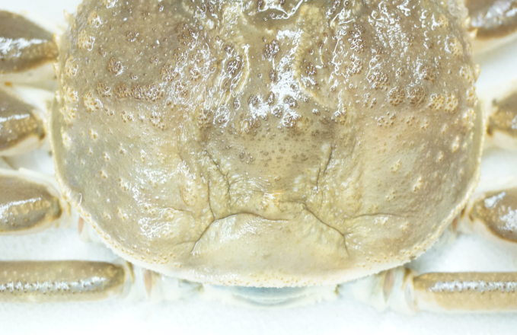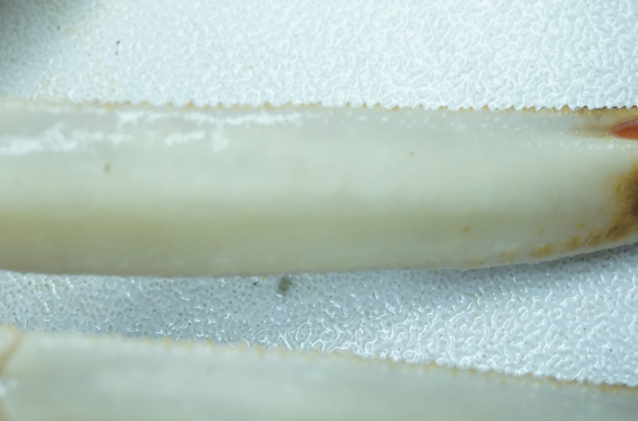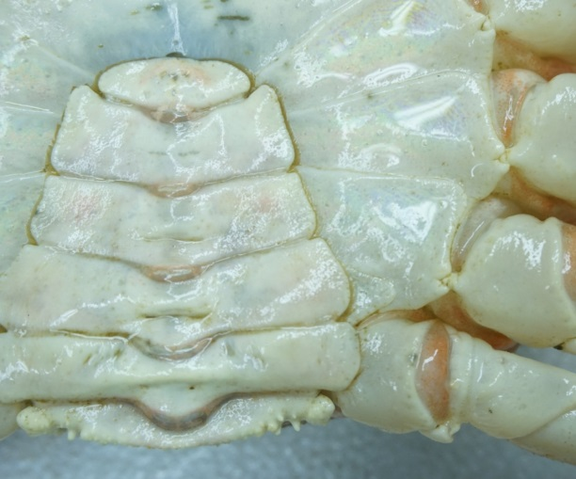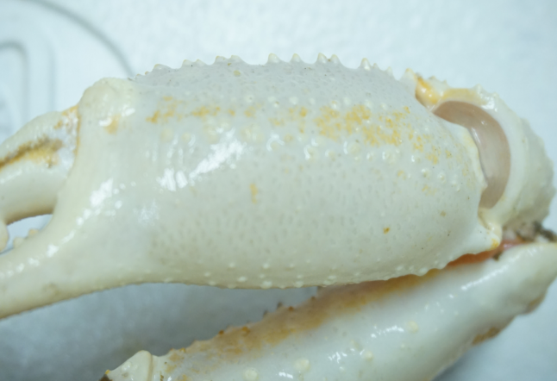

**Figure 1 :** Measurement locations on male snow crab for evaluating the performance of the colourmeter in predicting shell condition observations. The locations are, from top to bottom in the reading direction: 1) Intestinal region on dorsal surface, 2) 3rd abdominal segment (ventral), 3) Thoracic sternite, 4) Merus of the 2nd pereopod (lower ventral side), and 5) Cheliped (lower ventral side).

**MODEL**

* The shell condition observations were fit using an ordered multinomial logit model, using the colourmeter measurements as predictors.
* The model is described as follows:

**RESULTS**

Table 2 shows the summary results of the multinomial logit model fitted to various colorimeter data sets. For the Zone 12 May-June 2016 sample, the ventral cheliped data was ranked the best of the 5 measurement locations, with respect to model fit, with an AIC value 6.4 units less than the next best model (the ventral merus), as well as its misidentification error rate, calculated by comparing observed and predicted shell conditions from the model. The overall misidentification error rate was 13.8 % when one considered all shell categories individually (e.g. proportion of 3 versus 3M mix-ups by the model). The error rate for shell condition 2 versus all others combined was low at 0.25%. Based on these results the cheliped was chosen in favour of other locations for summer and fall samples.

One may visualize the above problem of identifying shell condition using a chromaticity plot (i.e. a scatterplot of a and b measurements only). Figure 2 shows the plot for the spring cheliped data. While the luminosity *L* is useful in separating the different shell condition categories, the chromaticity variables are where most of the variation between shell conditions lie. As was indicated be the model error rates, there is little overlap between shell condition 2 individuals and other categories. In contrast, there is considerable overlap between 3 and 3M categories, though these categories are separated somewhat in the luminosity (L) dimension (not shown). There is some overlap between shell condition 4 with both 3 and 3M.

The multinomial-logit model was also fit the cheliped data from September 2015 as well as the July and September of 2016 were also analyzed, first individually by month and then combined. For these periods and location (i.e. Zone 19), the misidentification error rates when considering all shell conditions individually were higher at 27.4 % for the July 2016 sample, 80.0 % for the September samples, and 24.3 % when combined. The error rates between SC2 versus other shell conditions were also higher at 5.3% for the July 2016 sample, and 0.62 % for the September samples and 3.7% for the combined sample. The chromaticity plot for this data set is shown in Figure 3.

As the error rates from the model results indicated, the separation between shell condition 2 and other categories is not as clear as that of the spring 2016 samples. There is considerable overlap between 3 and 3M categories. There is considerable overlap between shell condition 4 with both 3 and 3M.

|  |
| --- |
|  |
| **Figure 2 :** Chromaticity plot (*a* and *b* color values) for the cheliped location by shell condition for the Zone 12 spring samples for 2016. |

|  |
| --- |
|  |
| **Figure 3 : Chromaticity plot** (*a* and *b* color values) **for the c**heliped data by shell condition for the Zone 19 July 2016 and September 2015 and 2016 samples. |

**Table 2** : Summary results of the multiniomial logit model fitted to colormeter measurements. The first five rows compare the model AIC values and misidentification error rates for each of the five measurement locations for the spring 2016 data set. The last three rows compare the error rates from the fall samples from 2015 and 2016 both combined and broken by month. The number of observations is indicated by *n*.

|  |  |  |  |  |  |  |
| --- | --- | --- | --- | --- | --- | --- |
| **Measurement**  **Location** | **Year** | **Month** | ***n*** | **AIC** | **Error Rate**  **(2vs3+)** | **Error Rate (overall)** |
| Intestinal region | 2016 | May-June | 392 | 897.6 | 28.3 % | 48.7 % |
| Abdomen | 2016 | May-June | 392 | 367.8 | 2.8 % | 16.8 % |
| Thoracic sternite | 2016 | May-June | 392 | 435.1 | 5.6 % | 20.7 % |
| Merus | 2016 | May-June | 392 | 282.8 | 3.1 % | 14.3 % |
| Cheliped | 2016 | May-June | 392 | 275.8 | 0.25 % | 13.8 % |
| Cheliped | 2016 | July | 778 | - | 5.3 % | 27.4 % |
| Cheliped | 2015-16 | September | 1584 | - | 0.62 % | 80.0 % |
| Cheliped | 2015-16 | Jul-Sep | 2362 | - | 3.7 % | 24.3 % |

**Table 3** : Estimated coefficients from the multinomial-logit model for the cheliped spring 2016 data set. Shell condition 2 was used as a reference category.

|  |  |  |  |  |
| --- | --- | --- | --- | --- |
| **Shell condition** | **Intercept** | **L** | **a** | **b** |
| 3 | -1.49 | -0.313 | -3.588 | 4.501 |
| 3M | 26.48 | -0.848 | -5.162 | 4.867 |
| 4 | 55.80 | -1.482 | -5.729 | 5.348 |

* **Need more samples, but color sampling takes 1.5 minutes/individual onboard;**
* **If this method is deemed to be efficient/usable, a Bluetooth-enabled chromameter is required for sampling snow crab on a larger scale, as sampling per individual is on the order of 90 seconds or so.**

**SHELL CONDITION DIAGNOSTICS**

(**Condition 1** – **New soft**) The crab has moulted within approximately three months. The carapace that is soft or firm but flexible, the claw is easily broken under thumb pressure. The dorsal surface is light brown and the ventral one is translucent. Iridescence is apparent at different spots on the carapace. Neither wear nor scars are shown on the carapace, spines and dactyls are very sharp. The carapace is very clean with no visible epibionts. The meat yield is low at this stage.

(**Condition 2** – **New hard**) The crab moulted in the past three to 12 months. The carapace is more rigid and the claw is resistant under thumb pressure. The dorsal surface of the carapace is light brown and underneath is white and opaque. Iridescence is still visible at multiple locations on the carapace. No appearance of wear or scratches, spines are still very sharp. The crab is clean and the carapace may have presence of epibionts (i.e. moss, Balanus, Spiroide and leech eggs). Meat yield is medium at this stage.

(**Condition 3** – **Intermediate**) The crab moulted more than a year ago. The carapace is hard and firm. The claws are unbreakable under thumb pressure. The dorsal surface of the carapace is light brown and the ventral surface is yellow-beige. Iridescence only appears at a few spots on the carapace. Spines and dactyls are still sharp but signs of wear are visible. Scars are visible on the ventral surface. The meat yield is at its maximum level at this stage. This crab has very few or no moss spot (bryozoans) on the carapace. Other epibionts (Balanus and / or Spiroide) are generally present.

(**Condition 4** – **Old**) The carapace is hard and firm and the claws are unbreakable by simple thumb pressure. The dorsal surface is dark brown and the ventral surface is yellowish brown with no iridescence. Signs of wear and ageing are evident; with many scars and scratches on the carapace. Spines and dactyls are rounded. The organisms (moss, Balanus and / or Spiroide) are always present.

(**Condition 5** – **Very old**) The carapace is dirty and claws and articulations are softening due to decalcification. The dorsal and ventral surfaces are dark brown with no iridescence. Scars are everywhere on the carapace. Caparace wear is widespread, with spines and dactyls well rounded and often damaged. Epibionts (Bryozoa, Balanus and Spiroide) are always present.

* Meat yield is not a diagnostic criterion, it is related to carapace condition.

**Table X : Summary table of carapace condition diagnostic characters**

|  |  |  |  |  |  |
| --- | --- | --- | --- | --- | --- |
| **Condition** | **1** | **2** | **3** | **4** | **5** |
| Description | new soft | new hard | intermediate | old | very old |
| Relative age | <3 months | 3-12 months | > 1 year | > 1 year | > 1 year |
| Dorsal colour | light brown | light brown | light brown | dark brown | dark brown |
| Ventral colour | translucent | white opaque | yellow-beige | yellow-brown | dark brown |
| Iridescence | yes | some | limited | - | - |
| Wear / scars | - | - | traces | yes | yes |
| Spines / dactyls | sharp | sharp | slight wear | rounded | rounded |
| Balanus/Spiroide | - | some | some | yes | yes |
| Bryozoans | - | - | maybe a few | yes | yes |
| Meat yield | low | medium | high | high | high |

|  |
| --- |
| cid:image001.png@01D2EE83.D2C1AC00 |
| **Figure X :** OERA colorimeter data for female gonad. Different colours indicate *a priori* gonad colour code classifications. Two distinct clusters can be seen.   * **Gonad colorimeter data shows two distinct clusters, which suggests that the gonads are in two distinct phases of development.** * **Sample season partially, but not wholly, explains the presence of these clusters.** |